|  |  |
| --- | --- |
| Epics Used | 3.3 |
| US Used |  |

EVENT-AGENDA

Agenda - Elements

# Functional requirements

Part 2

11.10.2016

Created by: Alekseikova Anastasiya

a.alekseikova@andersenlab.com

Andersen LLS

# Types of the Agenda Elements

|  |  |  |  |
| --- | --- | --- | --- |
| **Elements** | **Types** | | |
| **Static Agenda Elements** | **Meetings Elements** | **Elements requiring table settings** |
| Presentation/Keynote | 1-2-1 meetings | Launch |
| Presentation/Debate |  | Dinner |
| Presentation/Chairman |  | Group Discussion |
| Presentation/Spotlight |  | 1-2-many placeholder |
| Presentation/Panel Discussion |  |  |
| Headline |  |  |
| Awards Panel |  |  |
| Presentation/Case |  |  |
| Presentation/Cross-Function Keynote |  |  |
| Presentation/Fish Bowl |  |  |
| Presentation/Leadership Presentation |  |  |
| Presentation/SnapShot |  |  |

# General Elements in the view (US16041)

Event specific agenda is managed currently in the view Skynet / Event / Edit / Structure. This story describes how this agenda view needs to be updated to support new agenda elements.

Pic 1

## 2.1. Element header bar colors for the different types of agenda elements

* 1. Static agenda elements = Orange
  2. Elements requiring table setting = Green
  3. Meetings = Blue

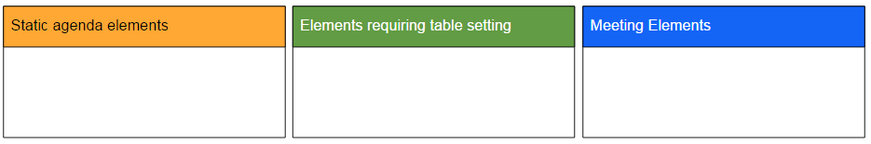Pic 2

## 2.2. Meeting booking "allowed" is shown in the element header

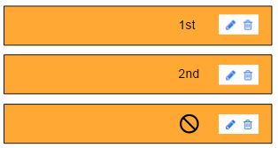

1. Primary meeting hour = 1st
2. Secondary meeting hour = 2nd
3. No meetings allowed = "icon

## 2.3. Rooms

### 2.3.1. General

1. 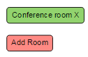Green button when room has been defined

room name shown in the button

1. Red button when room has not been defined

Button text "Add room"

### 2.3.2. Add room button

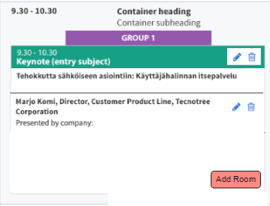

We need to be able to define in which room each agenda element is taking place.

Room info is shown for ME users in Skynet (Event agenda view) and for Delegates and solution provider representatives in ME App (agenda "list" view, agenda element single views)

Pic 5

"Add room" button opens a pop-up view in which user can write the name of the room in which that respective agenda element takes place

1. Header for the pop-up view "Add room for [agenda element type] - [date] [time]

View shows a text field in which user types the room name

"Add room for Lunch - 14.07.2016 11:00 — 12:00" x

Save

Pic 6

1. "Save" button to save room name
2. (X) in the view to allow user to close the view without saving changes

### 2.3.3. Edit room

1. 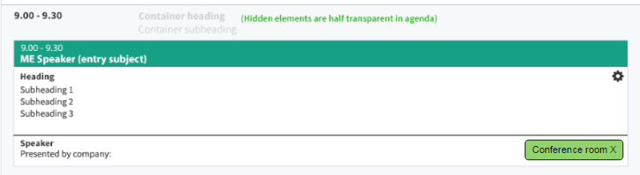The button [Room] turns to [Conference room] (the name of the button=the name in pic6)
2. User clicks the button that shows already defined room name (green button)
3. System open the view (Pic 6) and user is able to edit the text field with the room name
4. "Save" button to save changed room name
5. (X) in the view to allow user to close the view without saving changes

### 2.3.4. Adding info

-Room info should be added into all of the forms in which user is defining the agenda element specific settings.

-Similar update should be done for all agenda element setting views

* 1. Static agenda element view
  2. Meeting placeholder element view
  3. 1-2-many meeting placeholder element view
  4. Elements requiring table settings

## 2.4. "Add content" button

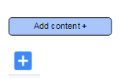

1. in empty element - "Add content +" button
2. when adding next one - "+"

minimized to save space

1. Add content allows user to attach presentations, spotlights, 1-2-many meetings etc to respective elements the same way as if they would open the element for editing.
2. Add content button is added to the all elements, except 1-2-1 meetings, dinner, launch and headlines (we have to be able to edit the headlines, but not to add smth)

​2.5. Group info

* 1. Group 1 / Group 2 on top of the element
  2. Check how it is placed in the wireframe picture on top of this page
  3. Note: as we have orange also used for one of the groups, we should probably use another shade to indicate group than what we use to indicate that element is "Static agenda element"

# Static agenda Elements

## 3.1. View in Agenda

**Chairman / Debate / Keynote / Panel discussion/Case/Cross-Function Keynote/FishBowl/ Leadership Presentation/Snapshot**

without presentation attached with presentation attached

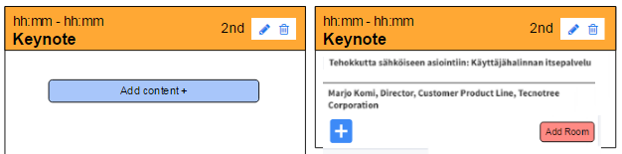

**Spotlight**

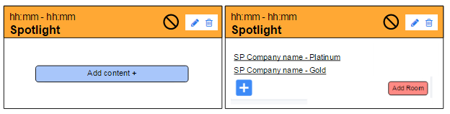 Without presentations attached With presentations attached

show company name + package type

**Awards Panel (US18563)**

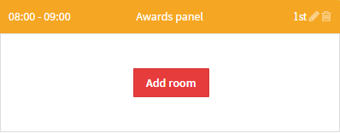

* The purpose of this new element is that in the app clicking the Awards panel element in the Agenda will direct the user to a new voting page that will list contacts that have been assigned to a candidate event role
* The new page and the functionality will be implemented separately

**"Generic text block" (exists — Headline) just for Static Elements!**

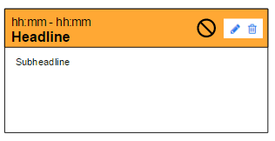

## **3.2. Element entry (US16018)**

### 3.2.1. Add entry button [Add element]



1. Click "Add entry"
2. Choose the type of Agenda element entry

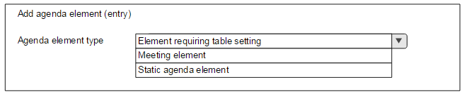

### 3.2.2 Chairman / Debate / Keynote / Panel discussion / Spotlight/ Case/Cross-Function Keynote/FishBowl/Snapshot/ Leadership presentation

(all added with the same settings in the form/view)

Agenda elements shown for users with static content. All users see these elements the same way. Visibility of these elements can be defined with delegate groups it those are in use.

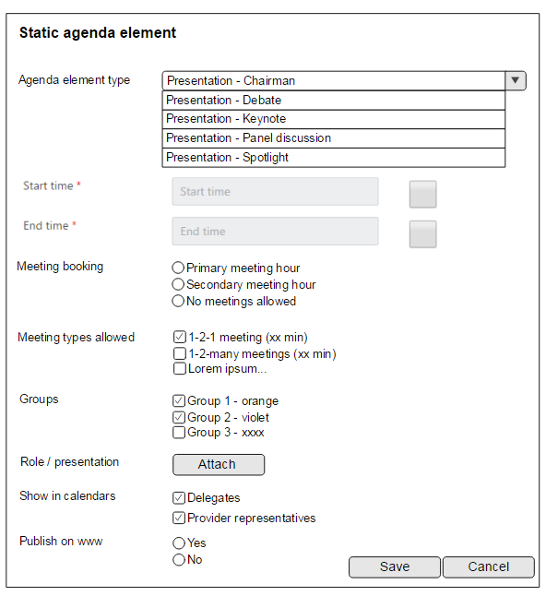

Start time (dd-mm-yyyy hh:mm)

End time (dd-mm-yyyy hh:mm)

check boxes

-Delegates

-Provider representatives

Attach role/presentation

Speaker(s)

Host(s) name (Lastname, First name)

Host(s) title

Host(s) company

Topic / heading

Subheading

radiobutton selection allowing 1 option to be selected

-Primary meeting hour

-Secondary meeting hour

-No meetings allowed

-List of active meeting types in the system (when creating a template)

-List of meeting types defined valid for the events version (when element is managed event version specifically)

Define which groups have this element in their agendas

√ Group 1

√ Group 2

Group 3

Define if this element is shown on public www-pages

### 3.2.3. **Headline**

Add presentation relates to all types escept Headlines

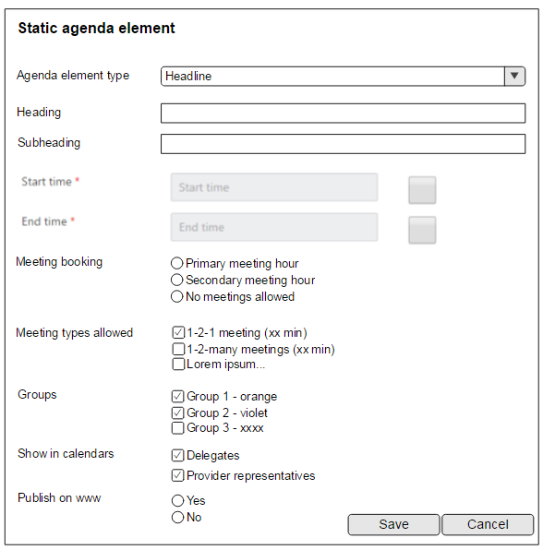

### 3.2.4. Awards Panel (US18563)

No hosts or presentations are added to this element

* The "Attach role/presentation" row & button is not displayed for this element type in the edit form
* Only Room is added to this presentation

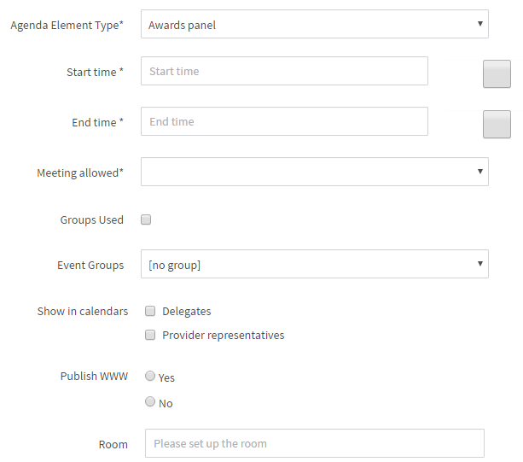

## 3.3. Managing presentations (US14502 US14485)

### 3.3.1. General:

* 1. Enable multiple speakers per presentation
  2. Speakers/presenters can be either delegates or solution providers AND we also need to be able to attach speakers who are not participating the event as a delegate nor as a solution provider

3) Primary meeting hour:

-scheduling algorithm uses 1st these slots

4) Secondary meeting hour:

-scheduling algorithm uses these as secondary slots

5) "Generic text block" element type does not include possibility to attach roles/presentations to it

6) Attach

- Open list of presentations with the same agenda element type (in the example above "Presentation / keynote")

- Choose presentation from the list (list only contains presentations that have not been already attached to the agenda) Pic 27

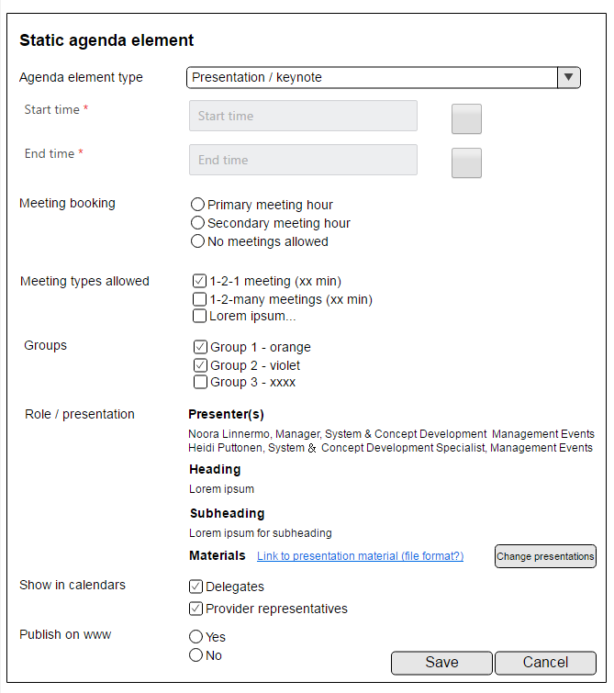

* Agenda Element types are hard coded into the system as stated below

- There is no need to provide management views to allow users to create new elements by themselves.

* Element type names need to be localized.

- Agendas show the local term according to the language used for that specific event version.

* System reserves xx min buffer for the presenters/speakers attached to these elements. This means that speakers' agendas are blocked and they cannot book meetings e.g. 15 min before the start of an element they are attached to. Pic 28

Static agenda elements are defined for the event through the program template (see user story "Agenda templates - creating templates in library"

### **3.3.2.** Attaching a presentation

1. The user clicks on the "Add presentation" button in the presentation entry / agenda element
2. A modal appears that displays the list of available and suitable presentations for that entry
3. The user selects one or several presentations and clicks the Save button.
4. The presentation(s) are attached to the presentation entry

### 3.3.3. Changing a presentation

* + 1. The user clicks on the "Add presentation" button in the presentation entry
    2. A modal appears that displays the list of available and suitable presentations for that entry
    3. The currently attached presentation is displayed as preselected

The user updates the selection, clicks the Save button and the presentation entry is updated.

### 3.3.4. Modal for selecting the presentation

1. **The header of the modal**

* [Presentation type] - Add presentation

1. **The available presentations are displayed in a table**
   * Columns
     + Select
     + Checkboxes for selecting one or many presentations
     + The settings of the presentation element define whether it's possible to attach one or several presentations to the presentation entry / agenda element
   * Heading
     + The main heading of the presentation
   * Speakers
     + A list of the speakers that have been attached to the presentation
     + Support for displaying multiple contacts (bullet list)
     + The field displays the company name, the first name and last name of the contact
     + The company name is displayed in bold
   * Organizer
     + The partner company whose partner package contains this presentation
     + If the presentation is not connected to a partner package but instead to a delegate's event role then "Management Events" is displayed in this field
   * Package
     + The partner package of the organizer / partner company
     + If the presentation is not connected to a partner package but instead to a delegate's event role then this field is empty
   * Buttons
   * Save
     + Attaches the selected presentation(s) to the presentation entry and closes the modal
     + The agenda is refreshed to display the attached content
   * Cancel
     + Closes the modal
   * Mouseover
     + Hovering the mouser cursor on top of a presentation displays the ID of the presentation
2. **​Validation**
   * Only presentations that match the following criteria are displayed in the list of selectable options:
     + Matching presentation type with the presentation entry / agenda element
   * E.g. if the type of the agenda entry/element is "Presentation / Keynote" then the selection modal displays only presentations whose presentation type is "Keynote"
     + Presentations that have been attached to some other presentation entry are not displayed. **Every presentation can only be attached to one element / entry.**
   * **Leadership Presentation (US18563)**

The same "Leadership presentation" type presentation can be attached to multiple agenda elements

1. E.g. the same presentation can be held twice - in the morning for group 1 and on the afternoon for group 2
2. For this two "Presentation / Leadership presentation" elements would be placed to the agenda of the event and the same leadership presentation would be attached to both of the elements.

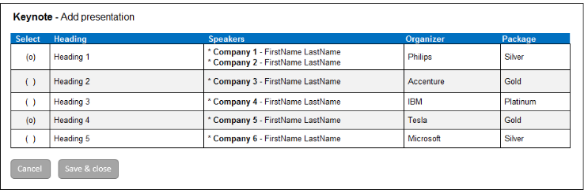

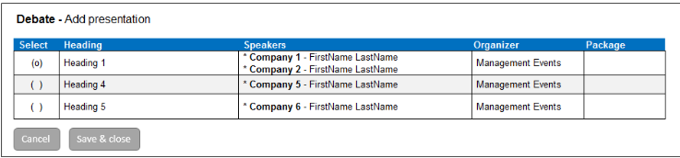

# 4. Elements requiring table setting

## 4.1. View in the Agenda

**Dinner / Lunch**

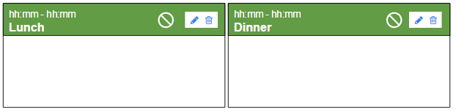Elements look always the same

**Group Discussion**

Without GD host + topic attached With host + topics attached

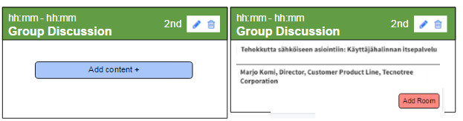

**1-2-many meeting**

Without meeting hosts attached With hosts attached

show company name + package type

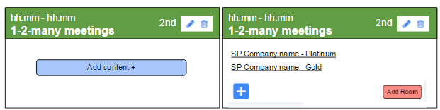

## **4.2.**Add entry button [Add element]



1. Click "Add entry"
2. hoose the type of Agenda element entry



## 4.3. Description (US13662)

Within these elements, delegates and solution providers' hosts are divided into tables. Each table has a host and x number of participants.

There are currently 3 types of agenda elements requiring table setting

1.1. Lunch/Dinner

* each table has a host
* chosen delegates and provider reps are seated in the tables
* agenda shows 1) table hosts 3) people in table

1.2. Group discussions

* + 1 delegate hosts the session and briefs everybody to the topic of the session
  + 1 solution provider rep hosts each table and leads discussion
  + chosen delegates are seated in the tables
  + agenda shows 1) session hosts 2) table hosts 3) people in table 4) topic for discussion

1.3. 1-2-many meetings

* + 1 solution provider rep hosts each table and leads discussion about a preselected topics
  + chosen delegates are seated in the tables
  + agenda shows 1) host 2) people in table 3) topic for discussion

**Agenda elements are defined for the event through the program template**

* Agenda Element types are hard coded into the system as stated below.
* There is no need to provide management views to allow users to create new elements by themselves.
* Element type names need to be localized
* Agendas show the local term according to the language used for that specific event version.
* Roles attached to delegates' & providers' event participation info define which users can be attached to these elements
* System reserves xx min buffer for the hosts attached to these elements. This means that hosts' agendas are blocked and they cannot book meetings xx min before these elements.

## 4.4. Element Entry

### 4.4.1 **Dinner / Lunch** (both added with the same settings in the form/view)

radiobutton selection allowing 1 option to be selected

-Primary meeting hour

-Secondary meeting hour

-No meetings allowed

Start time (dd-mm-yyyy hh:mm)

End time (dd-mm-yyyy hh:mm)

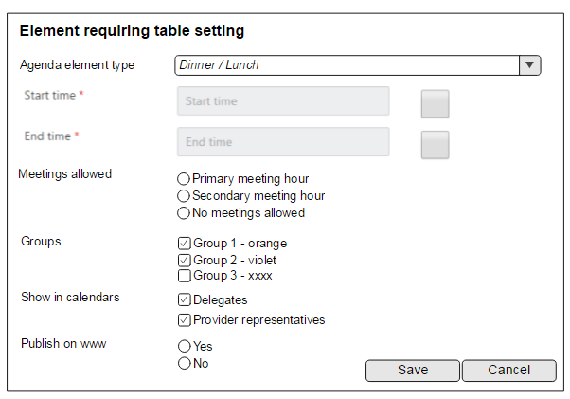Note:no session hosts, no topics à table hosts named automatically

Define which groups have this element in their agendas)

√ Group 1

Group 2

Group 3

check boxes

-Delegates

-Provider representatives

Define if this element is shown on public www-pages

### 4.4.2. **Group Discussion**

Session host(s) = Delegate(s) with a role "Group discussion presenter"

-Host(s) name (Lastname, First name)

-Host(s) title

-Host(s) company

-Topic / heading

-Subheading

View after session host/presentation attached:

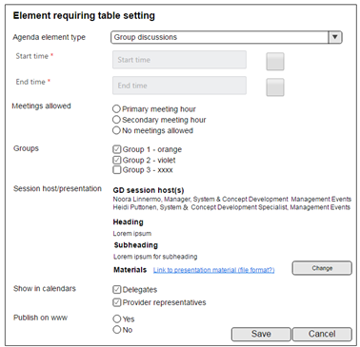

Change relates to the whole "Session host/Presentation" item - If user clicks change he/she will be able to pick another Group discussion initiator and related topic + description

### 4.4.3. **1-2-many meeting** Placeholder

### 4.4.3.1 Event specifically

1) ME users define which partners are attached to which elements and what is the max amount of people seated in one 1-2-many meeting table

2) Provider companies define

* heading/topic for the meeting
* subheading/description text
* rep to host each meeting

1. System generates 1-2-many meeting suggestions for delegates who are able to either accept or reject requests (suggestions are made based on matching between delegate's investments and host representative's event specific offering)

### 4.4.3.2. Managing 1-2-many meeting elements for event version:

1) Go to Skynet / Event / Structure

2) Click to open 1-2-many meeting element on the agenda

3) Modify event/element specific settings:

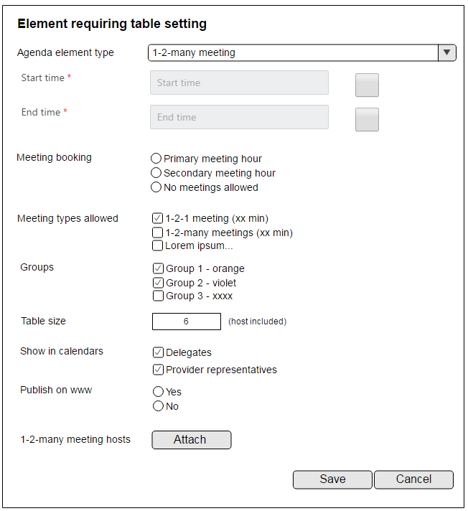Pic 22

1-2-many meeting placeholder

Primary meeting hour

Secondary meeting hour

No meetings allowed

3) 1-2-many meeting hosts

Start time (dd-mm-yyyy hh:mm)

End time (dd-mm-yyyy hh:mm)

list of meeting types marked to be valid for this event version

Table size = [number]

-amount of people that can be seated in one 1-2-many meeting table

(scheduling algorithm will utilize this info for generating 1-2-many meeting suggestions for delegates)

-includes both meeting host (provider representative) and delegates

4

1. "Attach" button allows adding provider companies 1-2-many elements to this specific agenda element
2. Open a list of 1-2-many meetings Pic 23

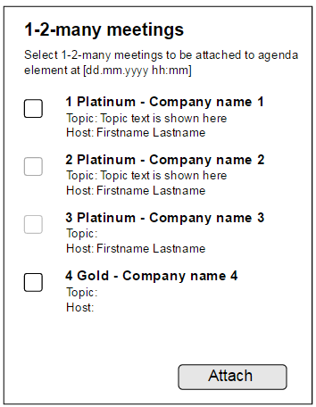

1. Choose meeting(s) from the list

- Meetings that have already been attached to another 1-2-many meeting element in the agenda are shown as inactive in the list and cannot be selected

1. 1-2-many meetings can be attached to agenda element even before provider company has names their hosts or defined their topics etc
   * 1-2-many meeting heading/subheading and host name may still be missing at this point
     + Once provider company names their host, defines meeting headings etc, they will become visible in this view as well

Pic 24

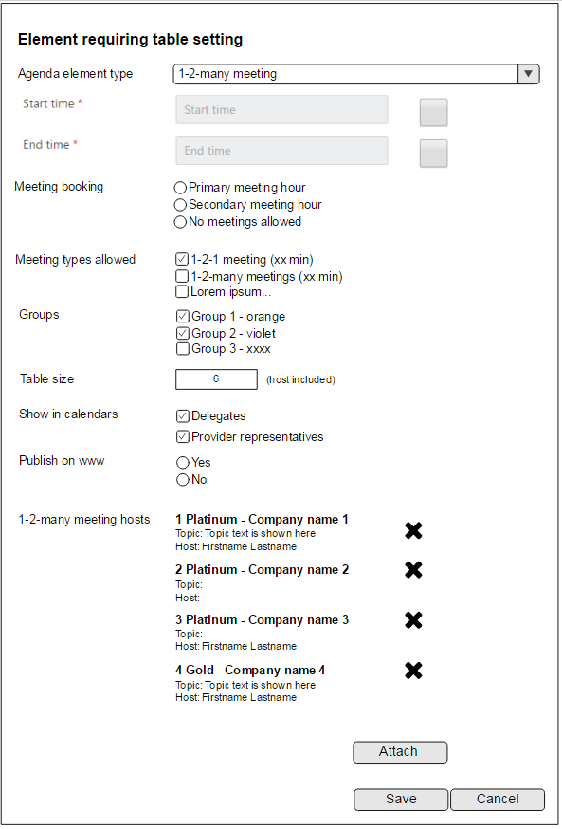6) Save

* + - Saves changes made in the view
    - User is left in the view after saving

7) Close

* Closes the view and user is returned back to agenda overview
  + If there are unsaved changes made, system will ask "Do you want to save changes made in the view?"
    - **Yes** - saves changes and closes the view and user is returned back to agenda overview
* **No** - closes the view without saving changes and user is returned back to agenda overview

Agenda element type

* Rename "1-2-many meeting placeholder" (despite what the wireframe above says)
* User is able to detach 1-2-many meeting from the element by clicking "X" / "Detach" button related to them
* Note: meetings should be detached only after user has confirmed changes with "Save"

### 4.4.3.3. Basics for 1-2-many meeting management

* Package defines how many 1-2-many meetings there are in provider's package (supported already in Skynet)
* New agenda element type "1-2-many meeting slot" defines where these 1-2-many meetings can be placed (this user story)
* Hosts, topics/subtopic will be defined
  + in ME App by the representative marked as 1-2-many host
  + in Skynet by ME users
  + 1-2-many meetings are attached to agenda elements manually as described in this US
  + System generates meeting suggestions for delegates to approve AND delegates can also book these meetings by themselves from the meeting booking views
  + Skynet will have a specific table setting view visualizing confirmed 1-2-many meetings table by table (US under construction)

# **Meeting Elements**

## 5.1. View in the Agenda

Element always looks the same

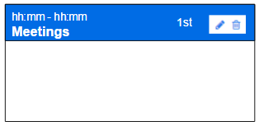

## 5.2. Element Entry

1-2-1 meeting Placeholder

